Option 1
- Duration & Effort
  - Say the development man days required 2200 (computed by analogy or regression)
  - 2200 /22 = 100 (convert to calendar month to apply the formula)
  - calendar time (months) = 1.07 * (100 ) ^{0.63} = 18.2
  - 18.2 + 1 (22 days for installation) = 19.2
  - * since training will be done concurrently with installation, training will not affect the schedule.

- Development Cost
  - 2200 man days * 1000 = 2,200,000
  - 2,200,000/18.2= 120,880 per month
  - 120,880 * 3 = 362,637 per quarter

- Installation Cost
  - 22 * 1000 = 22,000

- Training Cost
  - 3 days to prepare training material = 3 * 1000 = 3,000
  - 3 days to conduct = 3 * 1000 = 3,000
  - 10 End User, 3 man day per user, $700 per user = 21,000
  - Total = 3,000 + 3,000 + 21,000 = 27,000

- Maintenance Cost
  - 2,200,000 * 0.05 = 110,000/ per annual
  - 110,000 / 4 = 27,500 /per quarter
  - 27,500 / 3 = 9166 / per month

Option 2

- Duration & Effort
  - Say the development man days required 1300 (computed by analogy or regression)
  - 1300 /22 = 59 (convert to calendar month to apply the formula)
  - calendar time (months) = 1.07 * (59) ^{0.63} = 13.96
  - 13.96+ 1 (22 days for installation) = 14.96
  - * since training will be done concurrently with installation, training will not affect the schedule.

- Development Cost
  - 1300 man days * 2,500 = 3,250,000
  - 2,750,000 / 12.58 = 232,808 per month
  - 232,808 * 3 = 698,424 per quarter

- Installation Cost
  - 22 * 1000 = 22,000 (done by singma staff so the cost is 1000)

- Training Cost
  - Fix 5,000
  - 10 End User, 3 man day per user, $700 per user = 21,000
  - Total = 5,000 + 21,000 = 26,000

- Maintenance Cost
  - 20,000 per annual
  - 20,000 / 4 = 5000 per quarter
- Benefit

Since, the increase will be expected after the system launch, an increase will be seen in end of Q1 hence,

Q1 | 11000 | 550000
Q2 | 12100 | 605000
Q3 | 13310 | 665500
Q4 | 14641 | 732050
Q1 | 16105.1 | 805255
Q2 | 17715.61 | 885780.5
Q3 | 19487.171 | 974358.55
Q4 | 21435.8881 | 1071794.405

Assumption
- Both options yield the same benefits
Option 1:
Year | Qua | Description | Cost | Description | Benefit | Cashflow | Remarks
1 | 1 | Development | 362,637 |  |  | -362,637
1 | 2 | Development | 362,637 |  |  | -725,274
1 | 3 | Development | 362,637 |  |  | -1,087,911
1 | 4 | Development | 362,637 |  |  | -1,450,548
2 | 1 | Development | 362,637 |  |  | -1,813,185
2 | 2 | Development | 386,815 |  |  | -22,000,000
2 | 3 | Installation + training  + Maintenance  22,000 + 27,000 +  ((3-1.2) * 9166) = 16,500 | 65,500 | Benefit  10,000 *  1+ (0.1 * (1.8/3))  = 1.06  = 10,600 * 50 =  = 530,000 | 530,000 | -1,735,500 | First 0.2 (19.2-18=1.2) month is still under training.  10,600 increase in customer for 1.8 months
2 | 4 | Maintenance | 65,500 | 10,600 * 1.1 =11660  11,660 * 50 | 583,000 | -1,218,000
3 | 1 | Maintenance | 65,500 | 11,660 * 1.1 =12,862  12,862 * 50 | 641,300 | -642,200
3 | 2 | Maintenance | 65,500 | 12,862 * 1.1 =14,148  14,148 * 50 | 707,410 | -290
3 | 3 | Maintenance | 65,500 | 14,148 * 1.1 =15,562  15,562 * 50 | 778,140 | 712,350
3 | 4 | Maintenance | 65,500 | 15,562 * 1.1 = 17118  17118 * 50 | 855,910 | 1,502,760

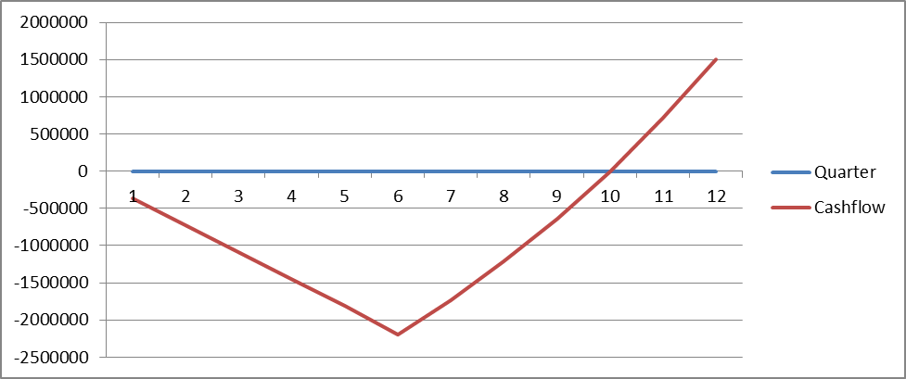

Option 2:
Year | Qua | Description | Cost | Description | Benefit | Cashflow | Remarks
1 | 1 | Development | 698,424 |  |  | -362,637
1 | 2 | Development | 698,424 |  |  | -725,274
1 | 3 | Development | 698,424 |  |  | -1,087,911
1 | 4 | Development | 698,424 |  |  | -2,793,696
2 | 1 | Development + Installation +  Training  456,304 +  22,000 +  26,000 | 504,304 |  |  | -3,298,000 | For estimation, the 15-14.96 = 0.04 months for system go live and benefit and maintainance is not included. Assume the system will go live on 1st days of year 2 quarter 2
2 | 2 | Maintenance | 5000 | Benefit  10,000 * 1.1 =  11,000 | 550000 | -2,753,000
2 | 3 | Maintenance | 5000 |  | 605000 | -2153000
2 | 4 | Maintenance | 5000 |  | 665500 | -1492500
3 | 1 | Maintenance | 5000 |  | 732050 | -765450
3 | 2 | Maintenance | 5000 |  | 805255 | 39,305
3 | 3 | Maintenance | 5000 |  | 885780 | 920,085
3 | 4 | Maintenance | 5000 |  | 974358 | 1,889,333

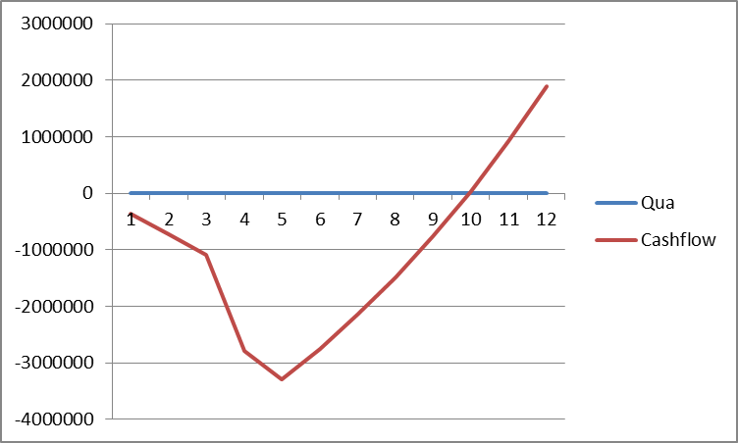

Risk
- Option 1
  - Risk
    - A static and dynamic shopping website is very different. Though they have experience in c#.net they may not have experience in building an ecommerce website. A poorly designed ecommerce site may result in customer refusal or lack confidence in using the website. Hence the investment may not yield the projected benefit as expected. This will be detrimental to SingaManga business

    - Installation and training has to be done concurrently to meet the schedule. SingaManga IT dept is mid-size, they may not have the resource to concurrently do the installation and training. Considering some may still need to provide support for other on-going production support.

    - Risk Management
      - Send their IT team for training
      - Detailed planning for schedule and resource to ensure they is enough resource, else escalate the issue to management to request for additional resource at the early stage of the project. It should later become a surprise to them
    - Lower in cost
  - Advantage
    - Better control over the project
    - Potential to become strategic tool
    - Good opportunity to build technical and domain skills
    - More customized functionality
    - Probably better maintenance service since its internal staff supporting
  - Disadvantage
    - risk of failure due to lack of functionality
    - Overload internal staff, need to do project need to support production
    - Probably required longer timeline
    - Higher maintenance cost
- Option 2
  - Risk
    - Vendor lock in /lock out
    - Functions may not meet user requirements

  - Risk Management
    - Detailed specs
    - Contact must clear state the damage cost if vendor is not able to deliver on time, deliver with a lot of bugs
    - Timely status update from vendor
    - Clear milestones and deliverables
    - Detailed specs

  - Advantage
    - Stability, tested and proven successful with track records
    - Shorter development time
    - Low maintenance cost
    - Allow current staff to focus on core competencies
  - Disadvantage
    - Less control over the project
    - Less customized to user needs
    - Less responsive maintenance service as it involves third party
Memoduram

Why Option 1:
Why unit testing
- Aims to discover bug at early stage of the project to ensure enough time to rectify
- Easier to discover bugs with a smaller set of the system
- Help to ensure integration can be done smoother

8.1
End to end
integration
12
9.1
Produce Test
plan

2
10.1
Plan field test

2
9.2
functional testing
12
9.3
performance testing
6
9.4
Security testing
6
10.2
install surpass on field trial devices
2
10.3
mobile phone field testing
7
10.4
PDA field testing
7
10.5
review results of field tests
3
11.1
Install surpass on all machines
9
12.1
acceptance meeting
1

